Krunal Intwala

2/25/13

IS 322 Homework

Your homework is to conduct an initial assessment and develop a mockup of a responsive web design.

You must choose an existing website that needs to be redeveloped as a responsive website.

Next, you need to create a series of wireframe mockups of websites that illustrate the changes that will take place when the site is viewed on the following devices:

1. Smart Phone

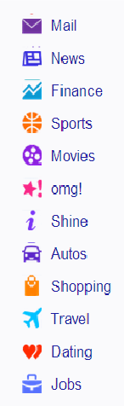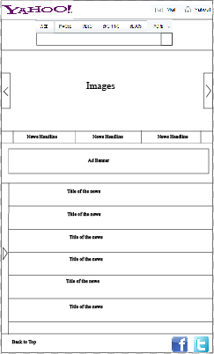

1. Mockup All contents texts are going to Times New Roman. Text can vary from 10 -12 depending on if it’s a title or description. For mobile and portrait version some of the description text will be truncated.
2. Arrow on the left side shows the yahoo menu.
3. Image size can have max width of 480. max Height of 186. Black padding will be created for width less than 480 and height less than 186.
4. Tablet – Landscape View

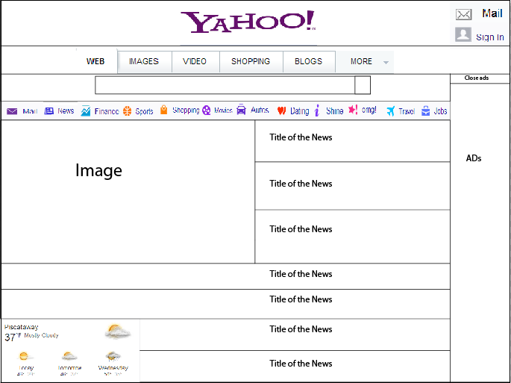

1. Mockup All contents texts are going to Times New Roman. Text can vary from 12 -14 depending on if it’s a title or description. For mobile and portrait version some of the description text will be truncated.
2. yahoo menu have moved to the top.
3. Image size can have max width of 511. max Height of 287. Black padding will be created for width less than 511 and height less than 287.
4. Tablet – Portrait View

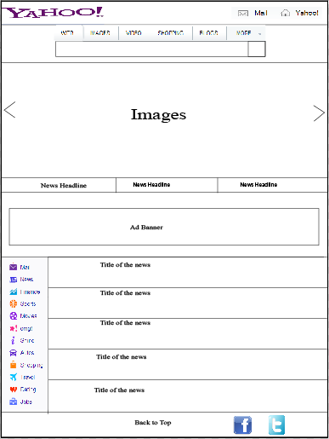

1. Mockup All contents texts are going to Times New Roman. Text can vary from 12 -14 depending on if it’s a title or description. For mobile and portrait version some of the description text will be truncated.
2. yahoo menu is shown on left bottom.
3. Image size can have max width of 768. max Height of 287. Black padding will be created for width less than 768 and height less than 287.
4. Parts of the two images are show. One on the left and one on the right.
5. Desktop – 1024px Resolution or less



1. Mockup All contents texts are going to Times New Roman. Text can vary from 12 -14 depending on if it’s a title or description. For mobile and portrait version some of the description text will be truncated.
2. yahoo menu have moved to the top.
3. Image size can have max width of 511. max Height of 287. Black padding will be created for width less than 511 and height less than 287.
4. Desktop – Greater than 1024px

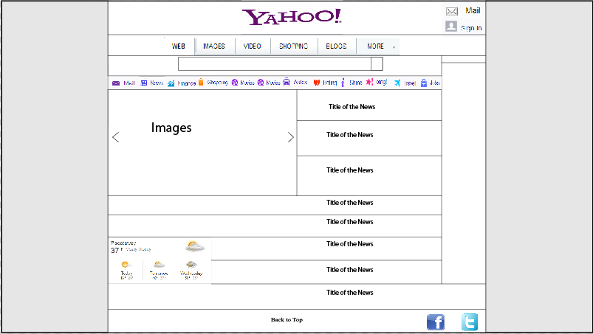

1. Mockup All contents texts are going to Times New Roman. Text can vary from 12 -14 depending on if it’s a title or description. For mobile and portrait version some of the description text will be truncated.
2. yahoo menu have moved to the top.
3. Image size can have max width of 511. max Height of 287. Black padding will be created for width less than 511 and height less than 287.

Each mockup should include:

1. A series of designs created using Adobe Illustrator or another design tool
2. Primary Navigation / Secondary Navigation with a font selected and example text
3. Content area with a font / example text
4. Feature area with a photo selected from iStockPhoto (use a free comp download)
5. Changes to navigation location
6. Indicate photo size changes
7. Location for at least one IAB approved advertisement size.

Deliverables:

1. Written explanation as to the purpose and audience of the website.
   1. It’s a search engine.